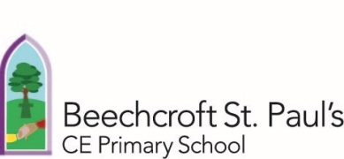



Soaring with compassion
Hope Respect Wisdom
Philippians 2: 1-4

Spirituality Policy

Spiritual development is essential to all children. At Beechcroft St Paul’s, we seek to ensure spiritual development is woven into daily life through educating the whole child in fullness across broad, rich curriculum opportunities. Spiritual development is not specific to one curriculum area or activity. Our school vision, “Soaring with compassion”, is built upon Philippians 2:1-4.
1Therefore if you have any encouragement from being united with Christ, if any comfort from his love, if any common sharing in the Spirit, if any tenderness and compassion, 2 then make my joy complete by being like-minded, having the same love, being one in spirit and of one mind. 3 Do nothing out of selfish ambition or vain conceit. Rather, in humility value others above yourselves, 4 not looking to your own interests but each of you to the interests of the others.

Beechcroft St Paul’s Primary School is a church school that is committed to encouraging the exploration of the Christian faith and values, while being open to other faiths, beliefs and values.
Pupils’ spiritual development is shown by their:
• Beliefs, religious or otherwise, which inform their perspective on life and their interest in and respect for different people’s feeling and values
• Sense of enjoyment and fascination in learning about themselves, others and the world around them, including the intangible
• Use of imagination and creativity in their learning
• Willingness to reflect on their experiences
The Church of England’s Vision for Education outlines a desire for life to be lived “ in all its full ness ” (John 10:10). It is also said that: “ For a human being, especially a child or young person, to have full quality of life, spirituality in all its aspects must be nurtured and affirmed ” (John Bradford)

Our Christian Values
Our Christian Values of hope, respect and wisdom are firmly rooted in our Christian vision. For further details regarding our values, please see our website.

Spiritual Development at Beechcroft St Paul’s through our Curriculum Drivers – a CASE for our curriculum
Our curriculum drivers (communication, aspiration, spirituality and environment) offer a CASE for our curriculum, acting as the backbone for our ongoing curriculum development. We are moving towards enquiry based learning, where each class will investigate a range of ‘Big Questions’ throughout the year, from Land of the dinosaurs – what clues are there? in year 1 to How does Islam’s past and present influence our lives? in year 6. Throughout this question-led approach to learning, opportunities for spiritual development are woven in.

Our belief about spiritual development can best be captured in our spirituality curriculum driver statement:

Spirituality
Our children need to understand themselves and take ownership of their thoughts and emotions. We will nurture all children, who through their learning and reflection can ‘still’ themselves. Our children will take an interest and delight in the world around them; they will be open to what lives beyond the material, which may manifest itself in faith. They will understand that differences between people should be celebrated and learned from. Our children will want to question the world around them in increasingly sophisticated and articulate ways and will seek to answer big questions.

To support staff with the interweaving of spirituality (as well as other curriculum drivers) throughout the curriculum, we have developed Curriculum Driver Progression Documents, which enable staff to consider how to further develop children’s spirituality. Once this is further embedded, we will look to share this work with children and continue to further develop our spiritual offering.

As a church school, Beechcroft St Paul’s believes that spiritual development is essential to the development of the whole child; we seek to offer a range of opportunities for children to develop their spiritual understanding. Opportunities for spiritual development are both planned and unplanned for as well as being exploited spontaneously. We are beginning to develop children’s understanding of how to reflect on their own development using the “Windows, Mirrors and Doors” concept, which we plan our acts of collective worship around.
Opportunity | What is involved?
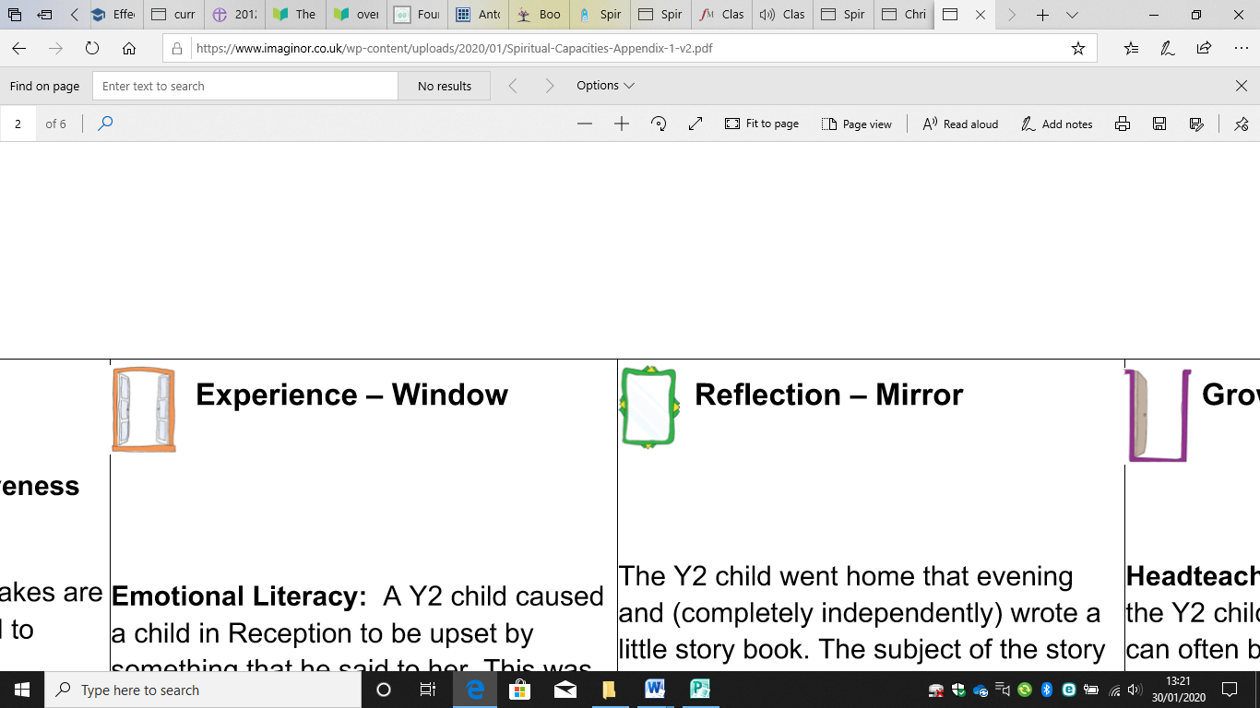  Windows on the world | Opportunities to look out on the world to gaze and wonder: The “Wow” and “Ows” moments. The things we find amazing and bring us up short.  We can wonder at the world, technology, art, music, scientific advances all around us. We may work outside, visit places of interest, celebrate inspirational people. We  can reflect on injustice and inequality in the world.  We can wonder at the beauty, technology, art,  music, scientific advances all around us. We may work outside, visit places of interest and celebrate the achievements of inspirational people. We can reflect on injustice and inequality in the world.
Self / Mirrors | Giving opportunities for children to reflect, to look inward to consider some of the big questions of life: To explore their own insights and those of others.  This could be compared with looking in a mirror. Look at yourself in a situation... How would you react, what would you say or do? These are questions which may arise through PSHCE lessons as well as daily life throughout school.
Beyond / Doors | Giving opportunities to children to respond, to do something to go through the door of a creative expression of their own thoughts and convictions.  Children would be living out our Christian values, considering how our own beliefs and faiths drive changes in the wider world and begin to seek to address injustice.

Spirituality section of Curriculum Progression Document:
 | Novice  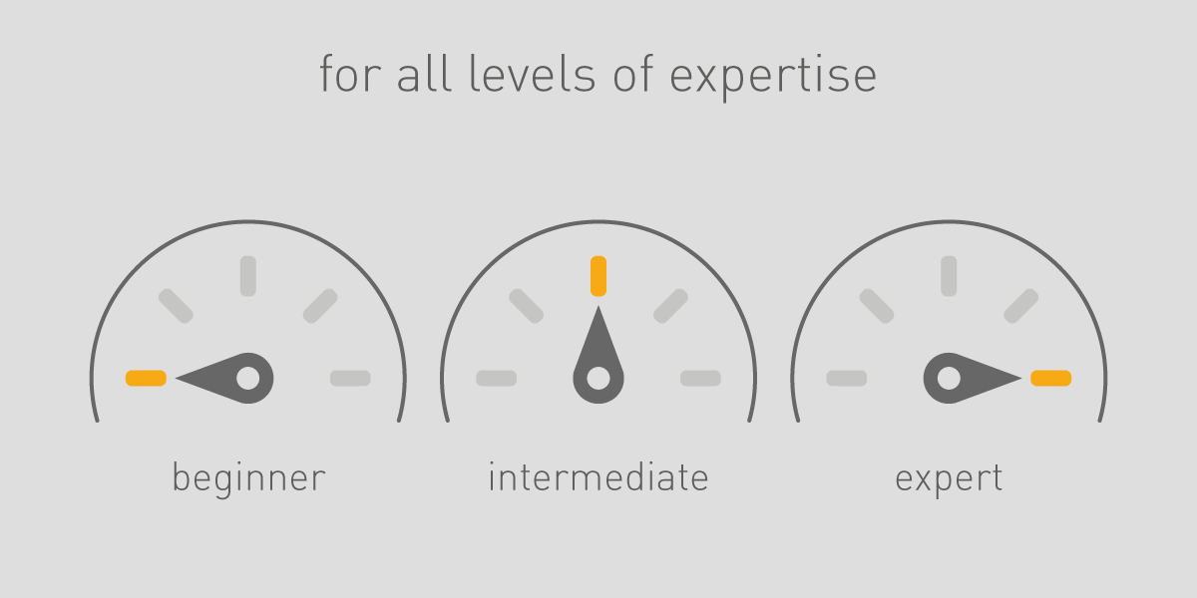 | Intermediate | Expert
Spirituality  To be global citizens, our children need to understand themselves and take ownership of their thoughts and emotions. We will nurture all children, who through their learning and reflection can ‘still’ themselves: Our children will take an interest and delight in the world around them; they will be open to what lives beyond the material, which may manifest itself in faith. They will understand the differences between people should be celebrated and learned from. | I can talk about how I feel  I know what makes me special  I am starting to think about what I may believe in  I sometimes try to answer ‘big questions’ (e.g. about life, death, suffering, nature of God)  I know that I am lucky in some ways  I show an understanding that one’s own behaviour affects other people  I listen to other people’s point of view  I find it hard to trust others  I stop and notice things in the world around me  I use reflection time to be quiet | I am able to talk and reflect about my feelings  I am happy with who I am  I am beginning to be able to explain my beliefs  I enjoy answering ‘big questions’ and sometimes think of my own. (E.g. about life, death, suffering, nature of God)  I can talk about what I am grateful for  I think of the effect of behaviour on others before acting  I can describe the points of view of others  I am respectful of different viewpoints to my own  I have a core group of people who I trust  I enjoy the miracles of everyday life in the world around me  I use reflection time to think and be still quietly | I am able to reflect on my own feelings and change my behaviour based on these reflections  I am proud of the things that make me special and know that it is ok to be different  I have a strong sense of what I believe in  I am able to discuss and challenge the ‘big questions’ respectfully (e.g. about life, death, suffering, nature of God)  I am aware that others do not always have what I do and am sensitive about this  I change behaviours to suit different situations  I describe and understand others’ points of view  I have a wide circle of people who I feel safe with and can trust  I make time to stop and reflect on the miracles of life in the world around me  I am able to ‘still’ myself and reflect when I feel it will help me

The four elements of spiritual development
Spiritual development can be encouraged through a range of activities. These will include both planned and unplanned learning opportunities. Children are encouraged to ask questions and explore topics, discussing and responding to issues around them.
Whilst spiritual moments can just happen, at Beechcroft St Paul’s, we are increasingly planning provide high quality, thought provoking and purposeful opportunities for spiritual development.
The four elements of spiritual development form the basis of our work with children in developing a strong sense of spirituality. We also believe that it is vital that all of the adults in school also see the need to develop their own spirituality for their own wellbeing and so that they can effectively support and help our children help each other.
Element | What does this involve?
Self | - Awareness of feelings; ability to reflect and express  - Awareness of our uniqueness; happiness with who we are  - Gratitude for the things we have and the person we are  - Exploration of personal faith  - Development of imagination and creativity
Others | - Empathy and understanding; respect, tolerance  - To love and be loved (loving your neighbour)  - Making a difference; duty
World | - Developing a sense of awe and wonder  - Enjoying the miracles of everyday life  - Taking time for what really matters  - Appreciating beauty in art, music, nature
Beyond (transcendence) | - Encountering/experiencing God (having a sense of what lies beyond the material/ physical)  - Ability to formulate and discuss the ‘Big Questions’ (e.g. about life, death, suffering, nature of God)  - Opportunities for prayer, connecting with God  - Making sense of the world

Opportunities to develop and support spirituality
Children will:
- Have regular times in the day for quiet and reflection. This might be listening to a story, lighting a candle in worship, engaging in reflection activities in spaces around school.
- Be provided with many opportunities for creativity and imagination.
- Be provided with purposeful and regular opportunities for prayer. This can take many forms, but should include being thankful and allow the children an opportunity to open themselves up to God.
- Have regular opportunities to explore, express and share feelings.
- See positive relationships role modelled around school. The importance of relationships will be reaffirmed to them. This will include clear exploration of how we talk to and relate to each other.
- Have opportunities to express awe and wonder, appreciate beauty in all its forms and appreciate connections and unity in the world.
- Be encouraged to reflect on mistakes and say sorry, where appropriate.
- Be encouraged to show perseverance, respect and trust and express these in practical ways.
- Have opportunities to explore ‘Big Questions’, particularly through RE learning, but also throughout our developing curriculum based on Big Questions.

Monitoring this policy
The impact of this policy will be monitored by the Headteacher and the Governors.
Discussions with all stakeholders will seek to identify how spiritual opportunities are being established and how these are impacting upon children’s understanding and development.

